**Step 1:**

Write a program in C to print first 50 natural numbers using ***recursion***.

*Expected Output* :

The natural numbers are : 1 2 3 4 5 6 7 8 9 10 11 12 13 14 15 16 17 18 19 20 21 22 23 24 25 26 27 28 29 30 31 32 33 34 35 36 37 38 39 40 41 42 43 44 45 46 47 48 49 50

Please attached the C-Program as a separate file, named=” C_50NaturalNum.c” for submission.

Note: Your C-program needs to be syntax error free and executable.

**Step 2:**

Use<https://godbolt.org/>, compile your source codes above onto ***x86-64***, using gcc5.4. An example of compilation is shown below:

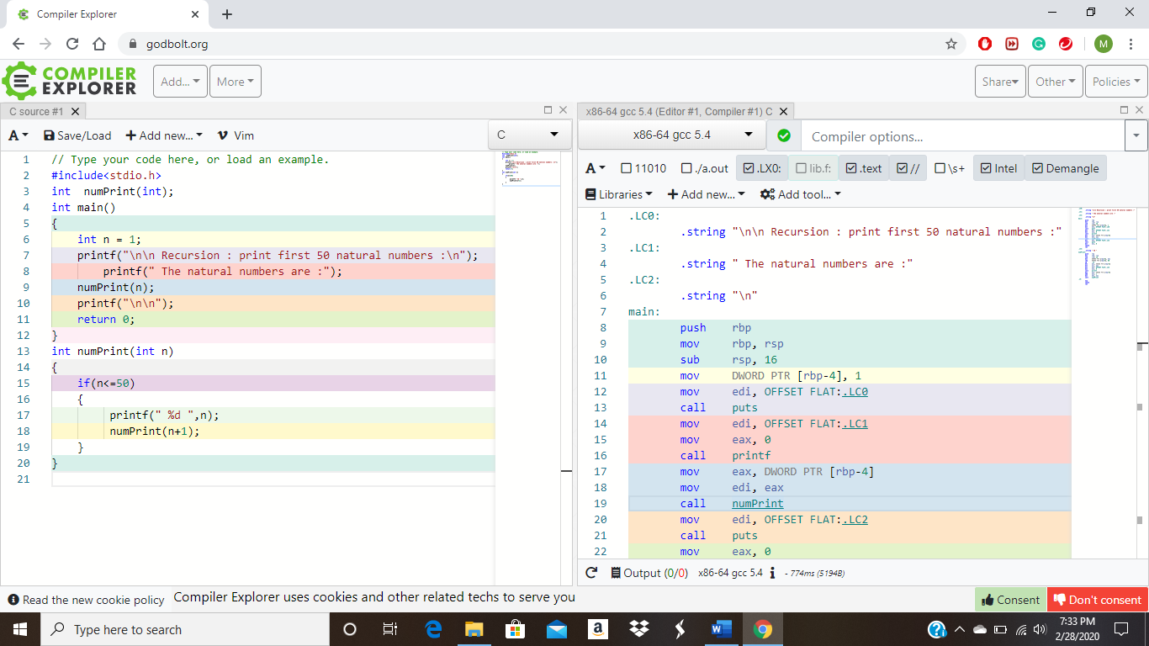

Save your compiled results into a file name=”x86_number.asm” for submission.

**Step 3:**

**Use** <https://godbolt.org/>,  **c**ompile your source codes above onto ***MIPS64***, using gcc5.4. An example of compilation is shown below:

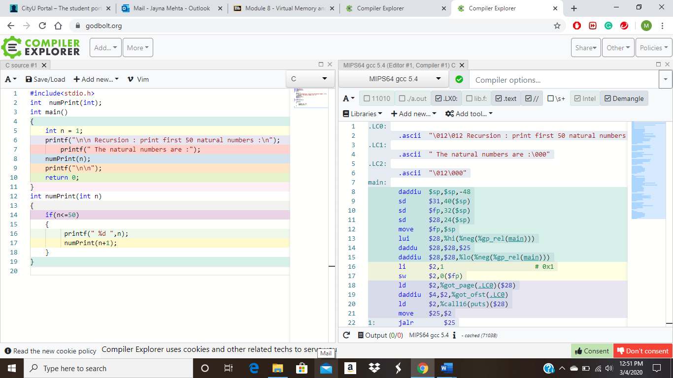

Save your compiled results into a file name=”MIPS_number.asm” for submission.

**Step 4:**

Per results above, complete the metrics on X86 vs MIPS, by filling the blank entries as outlined by the table below.

|  |  |  |  |  |  |  |
| --- | --- | --- | --- | --- | --- | --- |
|  | # of Lines in the .asm file | # of Instructions in the .asm file | # of Instruction Types | Program Memory Size | # of CPU to Memory Data Transfer Operations (e.g. MOV*) | Bonus: Total Execution Cycle Counts |
| X86-64 | 46 | 39 | 4 | 2KB | 17 Move operations |  |
| MIPS64 | 99 | 85 | 7 | 3 KB | 15 Move opeartions |  |

Suggestions:

* You may consider to use .xls to process the .asm files and extract the relevant info.
* You may consider to use Linux shell commands and RegEx to extract the relevant info.
* Bonus Points are tough, you will likely need to dive into the [X86 + MIPS] instruction Specs.

**Step 5:**

Your analysis and observations of x86-64 vs MIPS64, per metrics outline above, and beyond. Your additional insights and inputs are especially welcome.

[ For example: A better approach to measure the merits of using x86 vs MIPS processors? Can you simulate the codes with cycle-count accuracy? What about x86 vs ARM processors? This could be your Master thesis, or the bragging point in your job interview! ]

Please capture your inputs on the space below.

|  |  |  |  |  |  |  |
| --- | --- | --- | --- | --- | --- | --- |
|  | # of Lines in the .asm file | # of Instructions in the .asm file | # of Instruction Types | Program Memory Size | # of CPU to Memory Data Transfer Operations (e.g. MOV*) | Bonus: Total Execution Cycle Counts |
| X86-64 | 46 | 39 | 4 | 2KB | 17 Move operations |  |
| ARM | 45 | 36 | 5 | 2 KB | 2 Move opeartions |  |

